Tribute To Little Richard

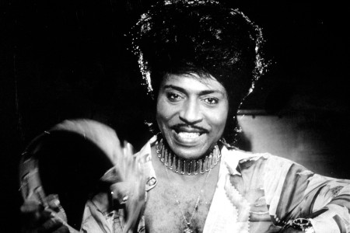

Little Richard, a founding father of rock & roll whose fervent shrieks, flamboyant garb, and joyful persona embodied the spirit and sound of that new art form, died Saturday. He was 87, and had suffered with bone cancer.

Starting with “Tutti Frutti” in 1956, Little Richard cut a series of unstoppable hits – “Long Tall Sally” and “Rip It Up” that same year, “Lucille” in 1957, and “Good Golly Miss Molly” in 1958 – driven by his simple, pumping piano, gospel-influenced vocal exclamations and often gibberish lyrics. “I heard Little Richard and Jerry Lee Lewis, and that was it,” Elton John told Rolling Stone in 1973. “I didn’t ever want to be anything else. I’m more of a Little Richard stylist than a Jerry Lee Lewis, I think. Jerry Lee is a very intricate piano player and very skillful, but Little Richard is more of a pounder.”

Although he never hit the Top 10 again after 1958, Little Richard’s influence was massive. The Beatles recorded several of his songs, including “Long Tall Sally,” and Paul McCartney’s singing on those tracks – and the Beatles’ own “I’m Down” – paid tribute to Little Richard’s shredded-throat style. His songs became part of the rock & roll canon, covered over the decades by everyone from the Everly Brothers, the Kinks, and Creedence Clearwater Revival to Elvis Costello and the Scorpions. “Elvis popularized rock & roll,” Steven Van Zandt tweeted after the news broke. “Chuck Berry was the storyteller. Richard was the archetype.”
Little Richard’s stage persona – his pompadours, makeup, and glass-bead shirts — also set the standard for rock & roll showmanship; Prince, to cite one obvious example, owed a sizable debt to the musician. “Prince is the Little Richard of his generation,” Richard told Joan Rivers in 1989, before looking at the camera and addressing Prince. “I was wearing purple before you was wearing it!”

“If you love anything about the flamboyance of rock & roll, you have Little Richard to thank,” says a longtime fan, “And where would rock & roll be without flamboyance? He was the first.”

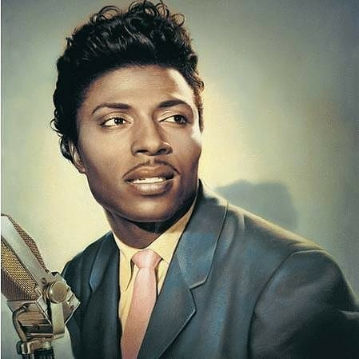

Born Richard Wayne Penniman on December 5th, 1932, in Macon, Georgia, he was one of 12 children and grew up around uncles who were preachers. “I was born in the slums. My daddy sold whiskey, bootleg whiskey,” he told a journalist. Although he sang in a nearby church, his father Bud wasn’t supportive of his son’s music, resulting in Penniman leaving home at 13 and moving in with a white family in Macon. But music stayed with him: One of his boyhood friends was Otis Redding, and Penniman heard R&B, blues, and country while working at a concession stand at the Macon City Auditorium.

After performing at the Tick Tock Club in Macon and winning a local talent show, Penniman landed his first record deal, with RCA, in 1951. (He became “Little Richard” when he about 15 years old, when the R&B and blues worlds were filled with acts like Little Esther and Little Milton; he had also grown tired with people mispronouncing his last name as “Penny-man.”) He learned his distinctive piano style from Esquerita, a South Carolina singer and pianist who also wore his hair in a high black pompadour.

For the next five years, Little Richard’s career advanced only fitfully; fairly tame, conventional singles he cut for RCA and other labels didn’t chart. “When I first came along, I never heard any rock & roll,” he told Rolling Stone in 1990. “When I started singing rock & roll, I sang it a long time before I presented it to the public because I was afraid they wouldn’t like it. I never heard nobody do it, and I was scared.”

By 1956, he was washing dishes at the Greyhound bus station in Macon (a job he had first taken a few years earlier, after his father was murdered and Little Richard had to support his family). By then, only one track he’d cut, “Little Richard’s Boogie,” hinted at the musical tornado to come. “I put that little thing in it,” he told Rolling Stone in 1970 of the way he tweaked with his gospel roots. “I always did have that thing, but I didn’t know what to do with the thing I had.”

During this low point, he sent a tape with a rough version of a bawdy novelty song called “Tutti Frutti” to Specialty Records in Chicago. He came up with the song’s famed chorus — “a wop bob alu bob a wop bam boom” — while bored washing dishes. (He also co-wrote “Long Tall Sally” while working that same job.)
By coincidence, label owner and producer Art Rupe was in search of a lead singer for some tracks he wanted to cut in New Orleans, and Penniman’s howling delivery fit the bill. In September 1955, the musician cut a lyrically cleaned-up version of “Tutti Frutti,” which became his first hit, peaking at 17 on the pop chart. “’Tutti Frutti really started the races being together,” he told Rolling Stone in 1990. “From the git-go, my music was accepted by whites.”

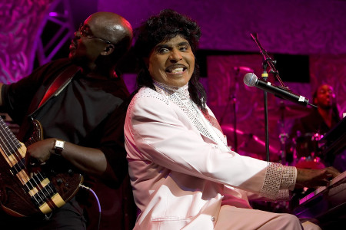

Its follow-up, “Long Tall Sally,” hit Number Six, becoming his the highest-placing hit of his career. For just over a year, the musician released one relentless and arresting smash after another. From “Long Tall Sally” to “Slippin’ and Slidin,’” Little Richard’s hits — a glorious mix of boogie, gospel, and jump blues, produced by Robert “Bumps” Blackwell — sounded like he never stood still. With his trademark pompadour and makeup (which he once said he started wearing so that he would be less “threatening” while playing white clubs), he was instantly on the level of Elvis Presley, Jerry Lee Lewis, and other early rock icons, complete with rabid fans and mobbed concerts. “That’s what the kids in America were excited about,” he told Rolling Stone in 1970. “They don’t want the falsehood — they want the truth.”

He was cast in a couple movies along the way as well. But then by his choice, the musical hits stopped. Penniman gave up music in 1957 and began attending the Alabama Bible school Oakwood College, where he was eventually ordained a minister. When he finally cut another album, in 1959, the result was a gospel set called God Is Real.

Little Richard made quite the impact on American music and influenced musicians around the world. Check out the Youtube videos that include an interview on 60 Minutes and some of his best-known hits. Click below and enjoy!

https://www.youtube.com/playlist?list=PLFukIqdgVdxf1zMjAHlvyzLXrNpqPoibm

