Community Services and Workforce Development
Senior Services Division
Presents

The Virtual Dementia Tour (VDT®) is the original and ground-breaking, evidence-based and scientifically proven method of building a greater understanding of dementia through the use of patented sensory tools and instruction based on research conducted by P.K. Beville, M.S., a specialist in geriatrics and the founder of Second Wind Dreams®.

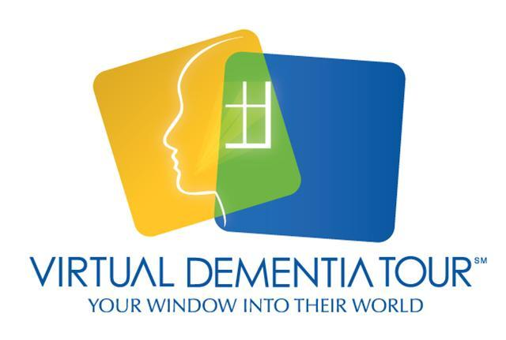
April 5, 2019

Cooper Green Mercy Health Services 1515 6th Avenue South Birmingham, AL 35233
9 a.m. – 2 p.m.
Call Dedra Lewis by 4/4/19 to register for a time slot.

(205) 325-5567
FREE AND OPEN TO THE PUBLIC

