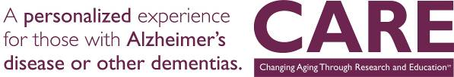

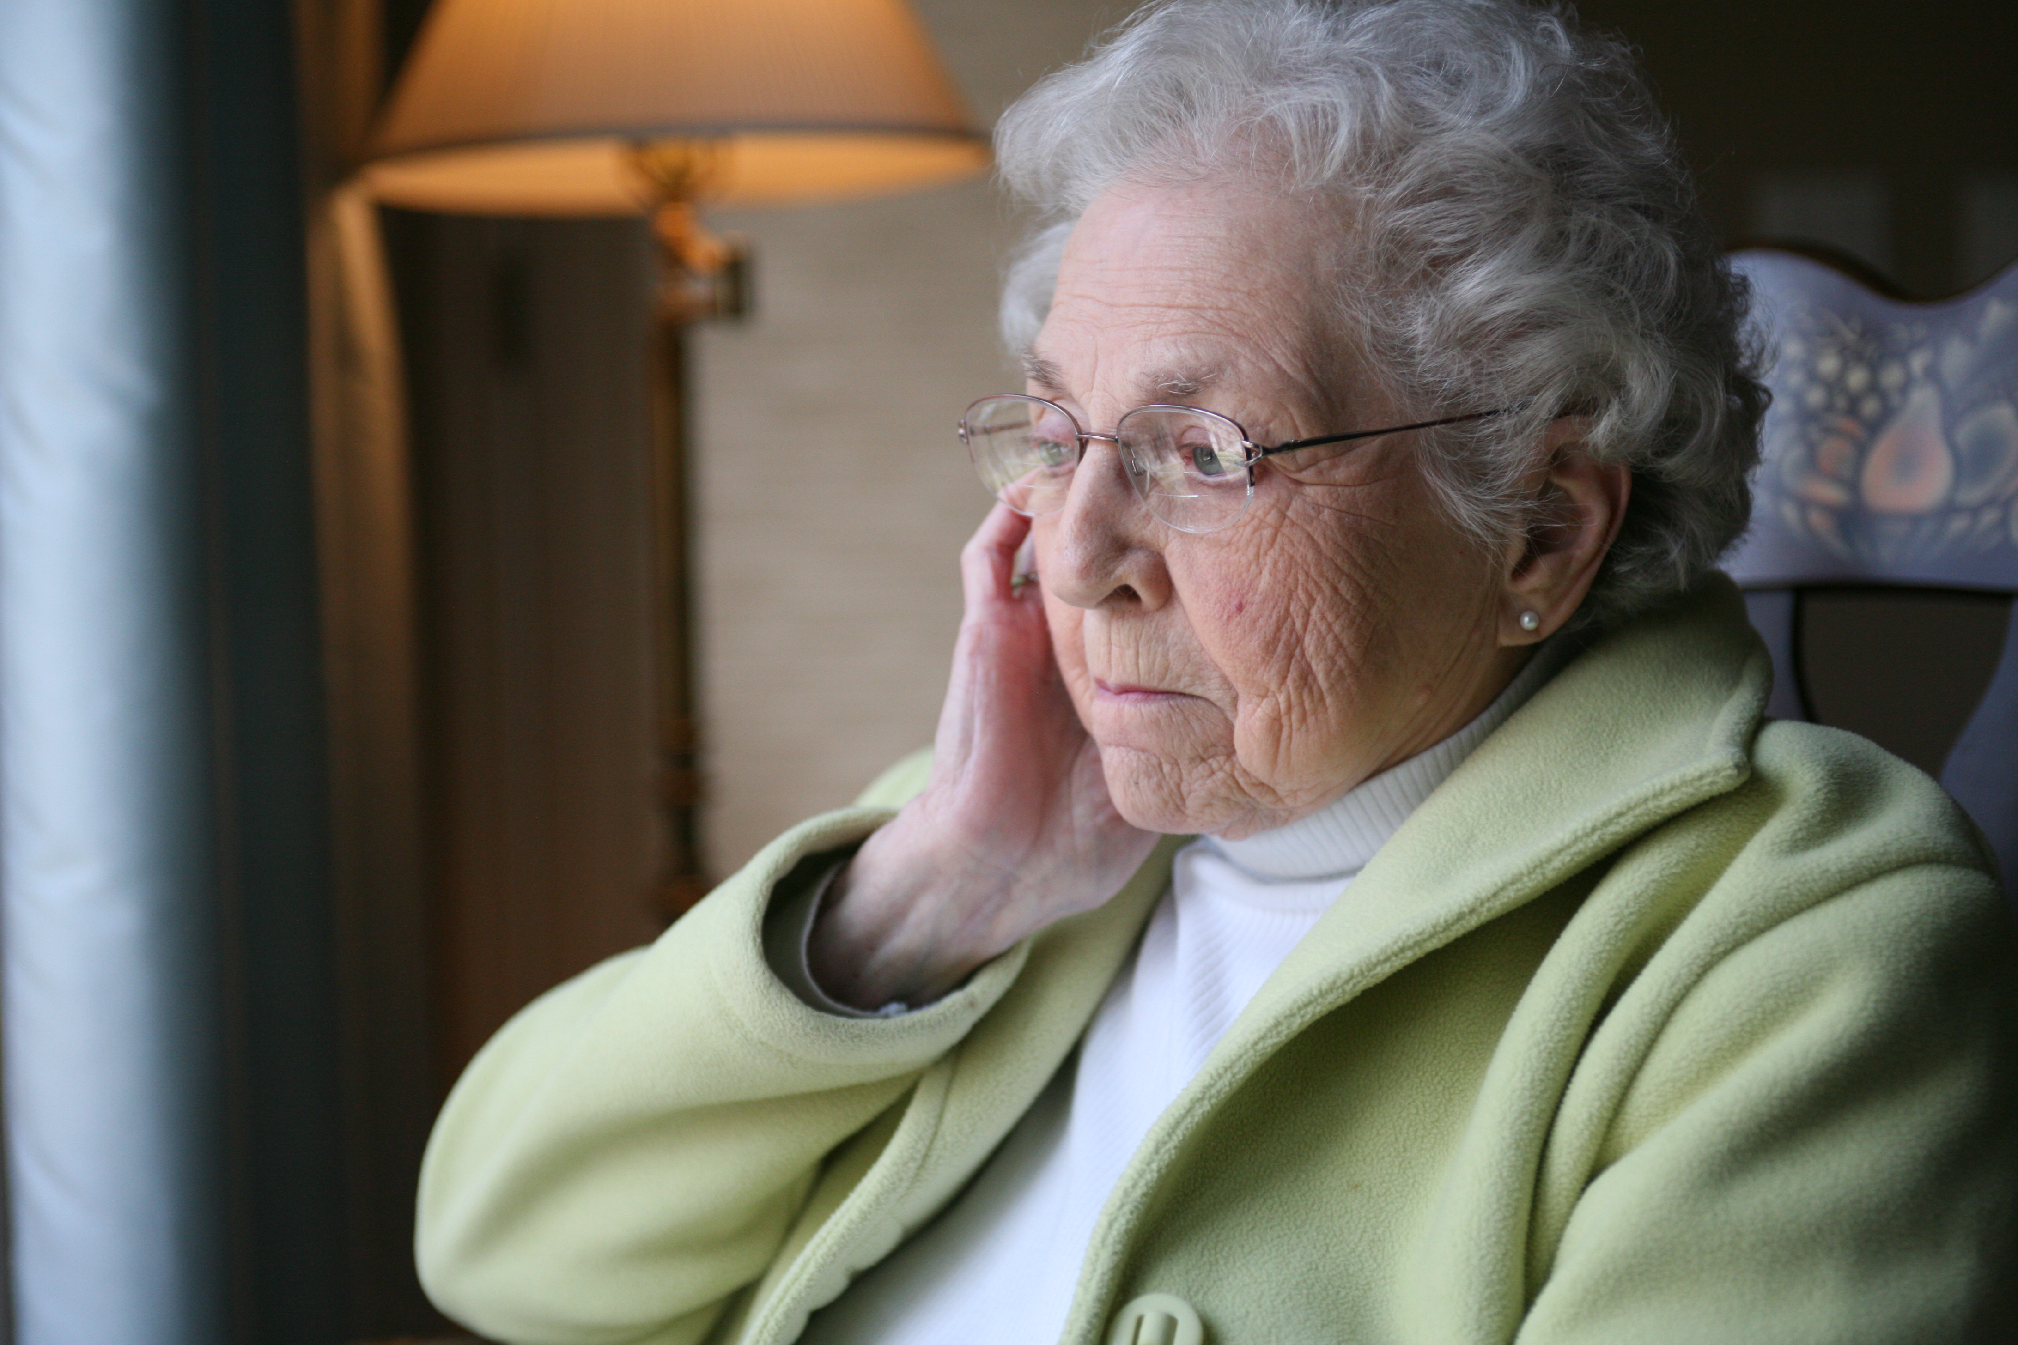
Is your loved one suffering from Alzheimer’s Disease or other dementias?

Please join us for a FREE Educational Workshop for those caring for a loved one with Alzheimer’s disease or other dementias.
The workshop will cover how to:
• Manage Behaviors
• Encourage Engagement
• Care for Yourself While Caring for a Loved One

HomeInstead.com/bham

DATE: Friday, April 5, 2019
TIME: 9:00 a.m. - 11:00 a.m.
LOCATION: 2059 Columbiana Road, Vestavia, AL 35216
RSVP by March 30 to 205.822.1915 or email kcochran@homeinstead.com
SPACE IS LIMITED

